Name: **Hewan Teklu**

Student ID # **2518543**

**Wireshark Lab 3 – TCP**

**IT 520-A – Enterprise Infrastructure & Networks**

Computer IP address on Terminal

10.0.0.102

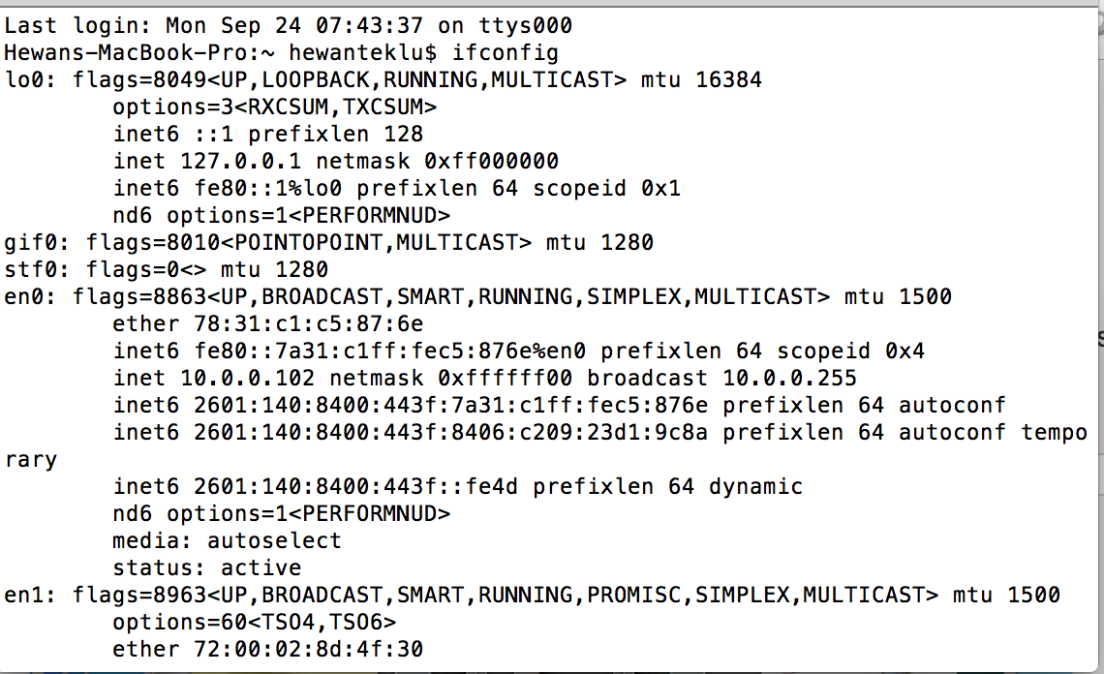

HTTP OK message PRINT

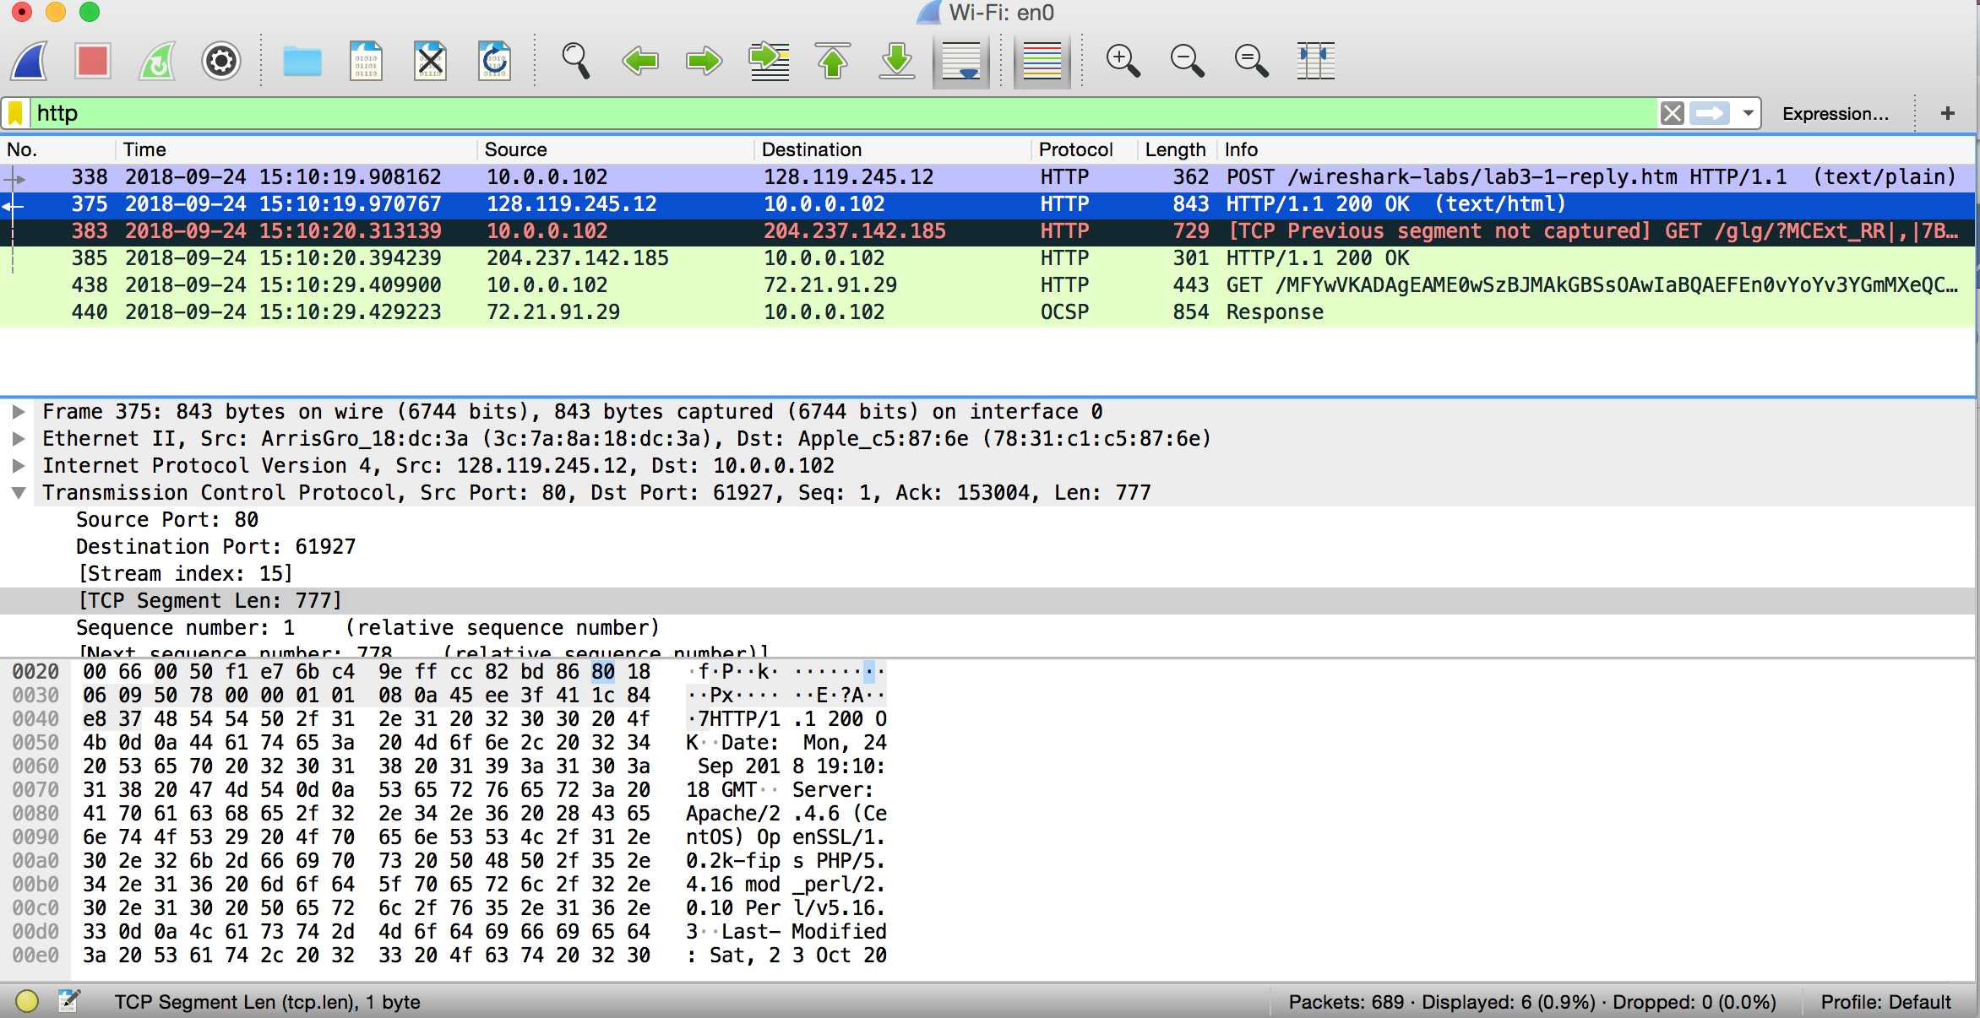

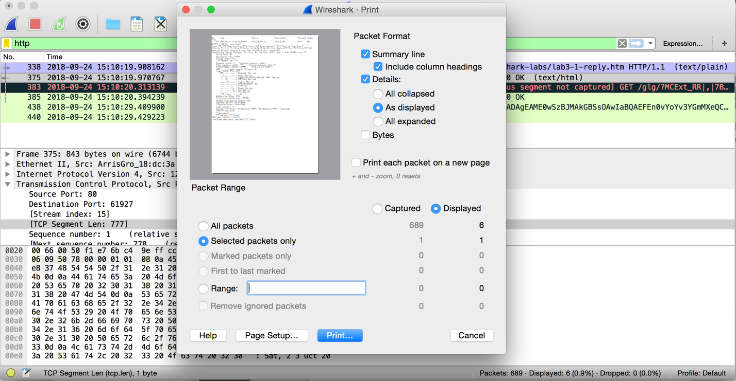

1. What is the TCP port number used by your computer to communicate with gaia.cs.umass.edu?

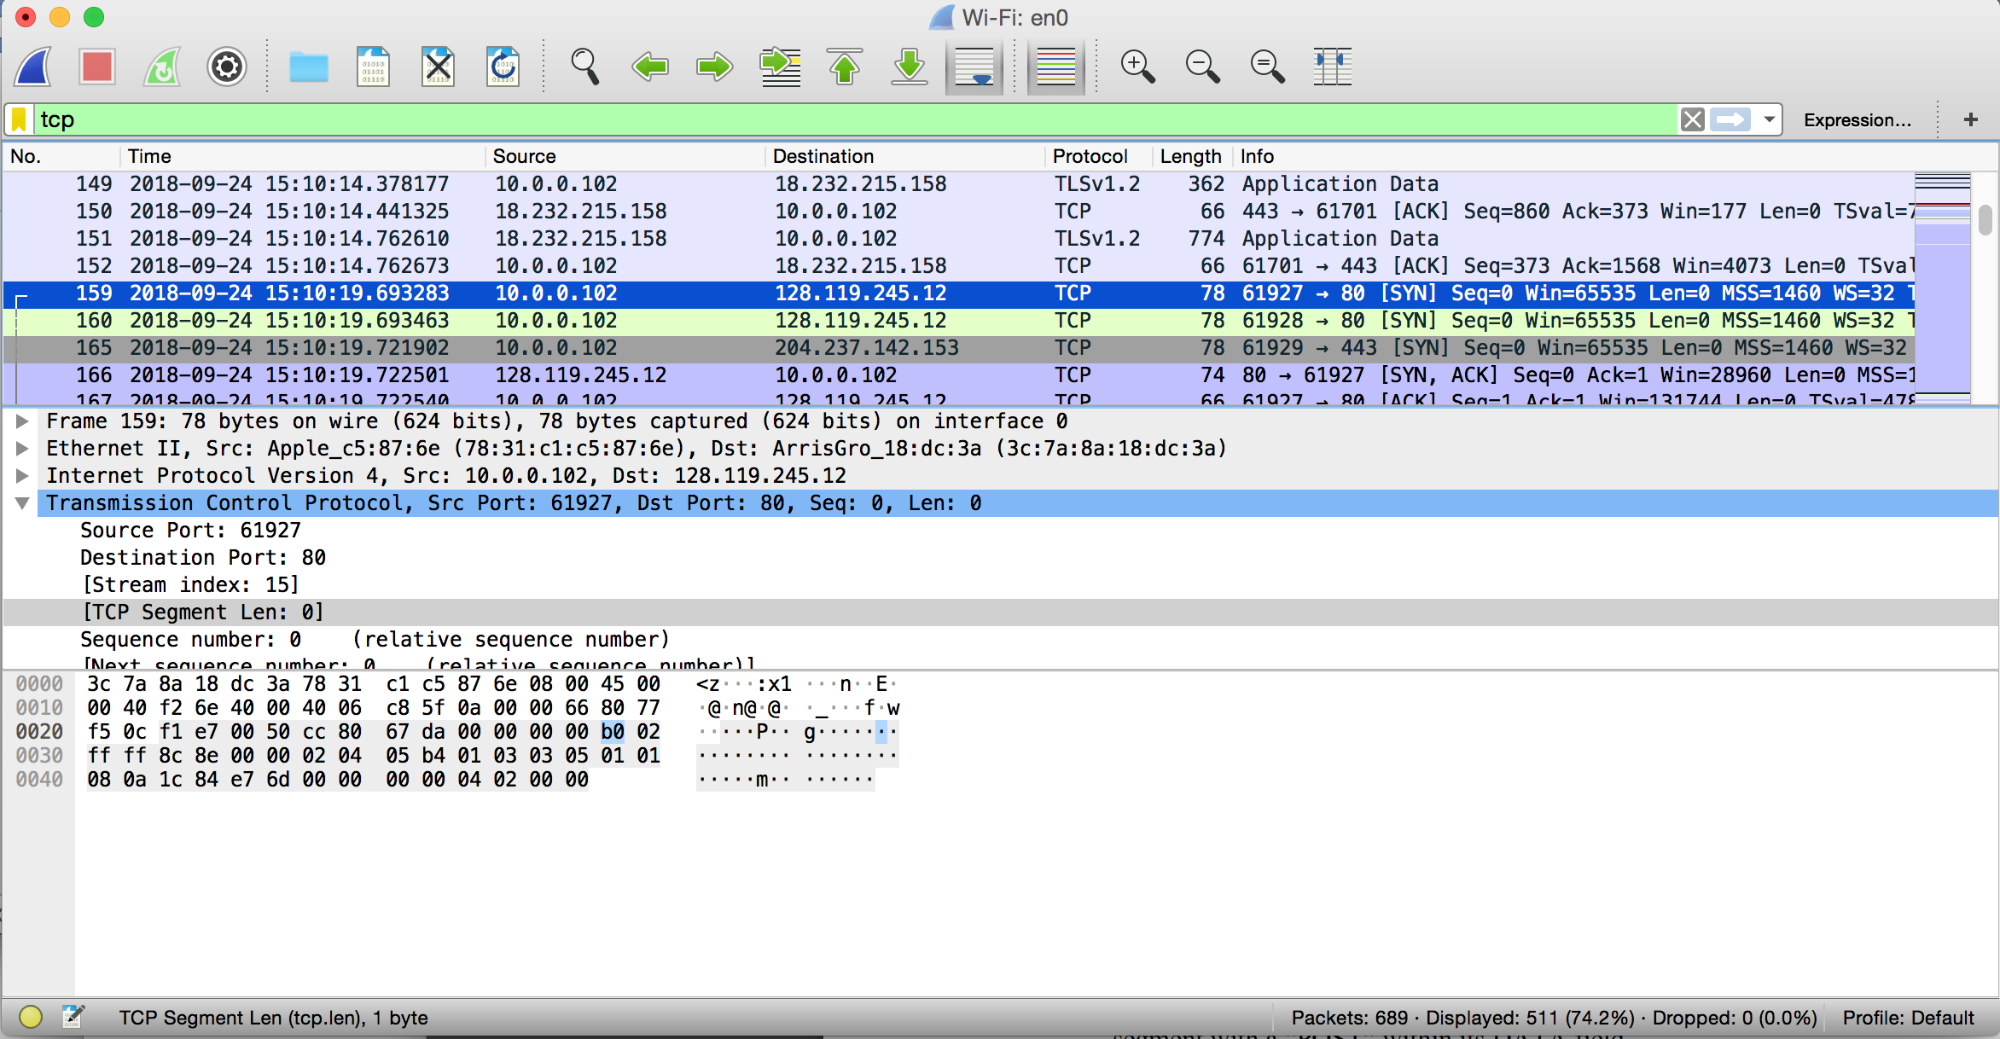

***Solution:***

TCP port number: 61927

1. What is the TCP port number used by gaia.cs.umass.edu to communicate with your computer?

***Solution:***

Destination TCP Port Number:80

1. What is the sequence number of the TCP SYN segment that is used to initiate the TCP connection between your computer and gaia.cs.umass.edu? What is it in the segment that identifies the segment as a SYN segment?

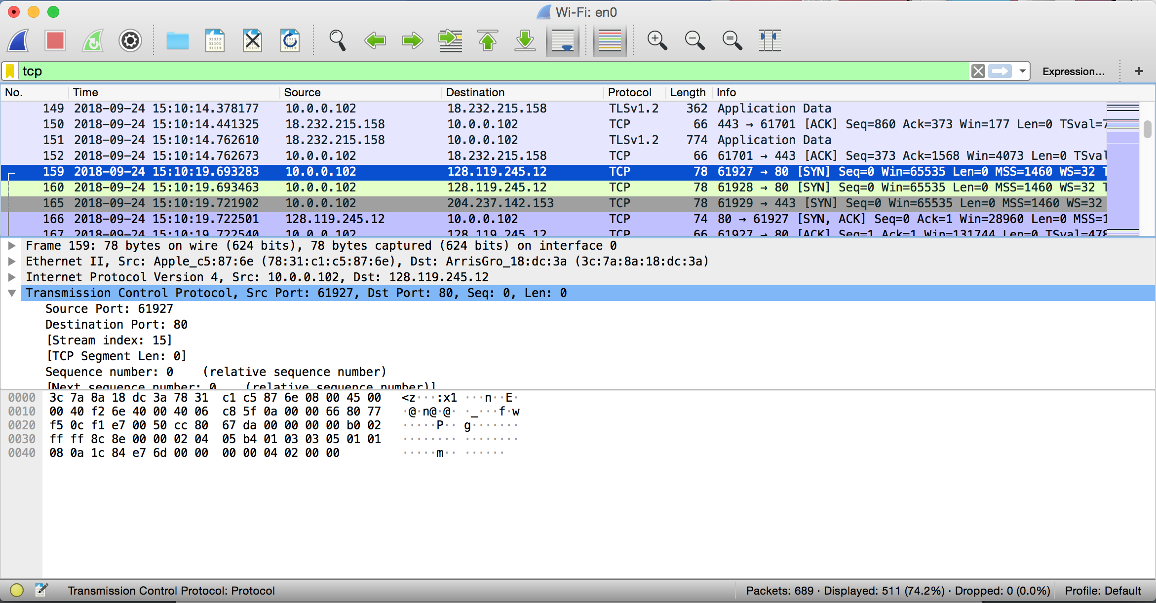

***Solution:***

Sequence Number is 0

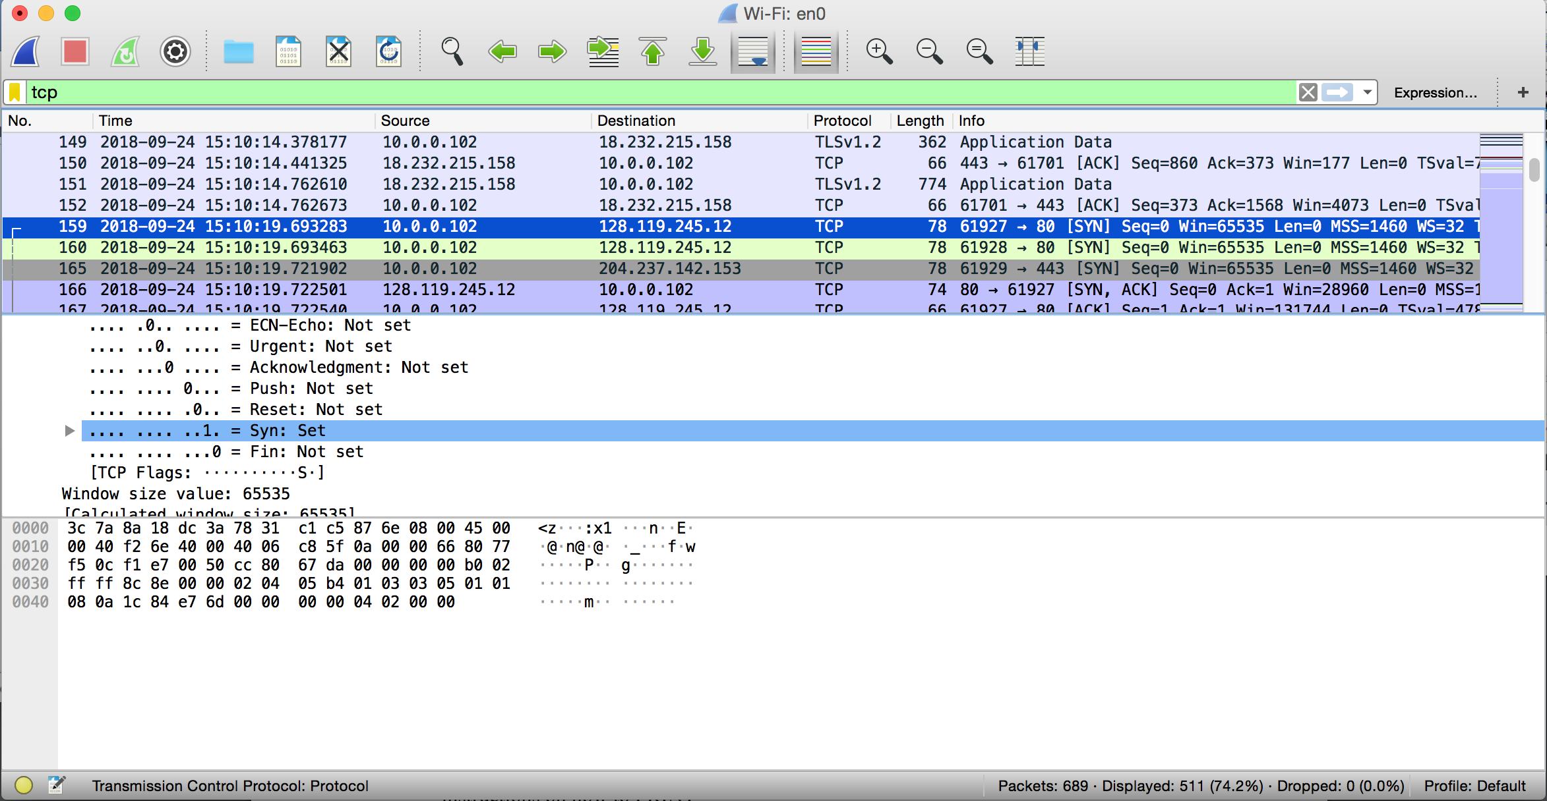

***Solution:***

1= SYN: Set

The SYN flag is set to 1 and it indicates that this segment is a SYN segment.

1. What is the sequence number of the SYNACK segment sent by gaia.cs.umass.edu to the client computer in reply to the SYN? - You must dig deep and find the ACK from gaia.cs.umass.edu.

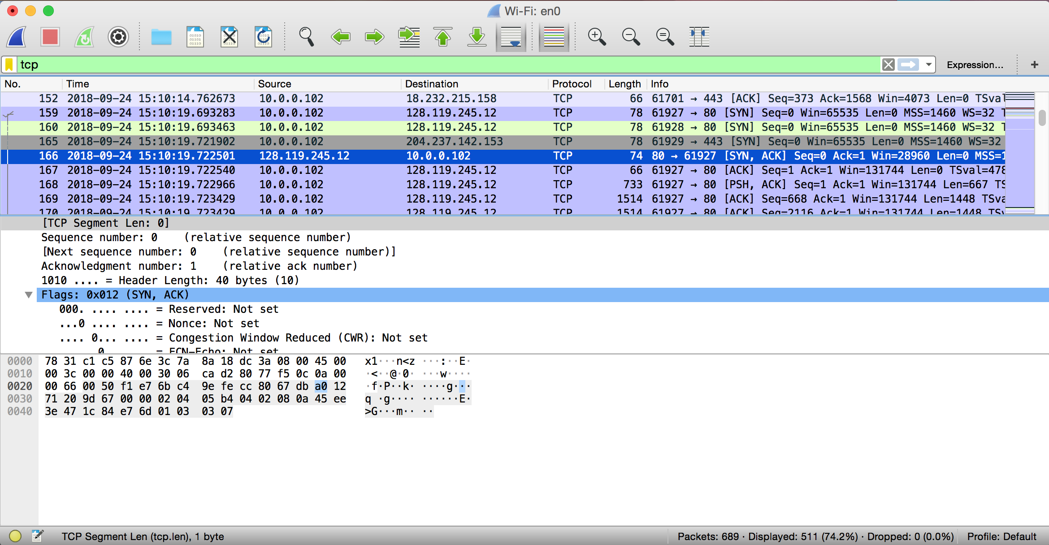

***Solution:***

Sequence number of the SYNACK segment from gaia.cs.umass.edu to the client computer in reply to the SYN has the value of 0.

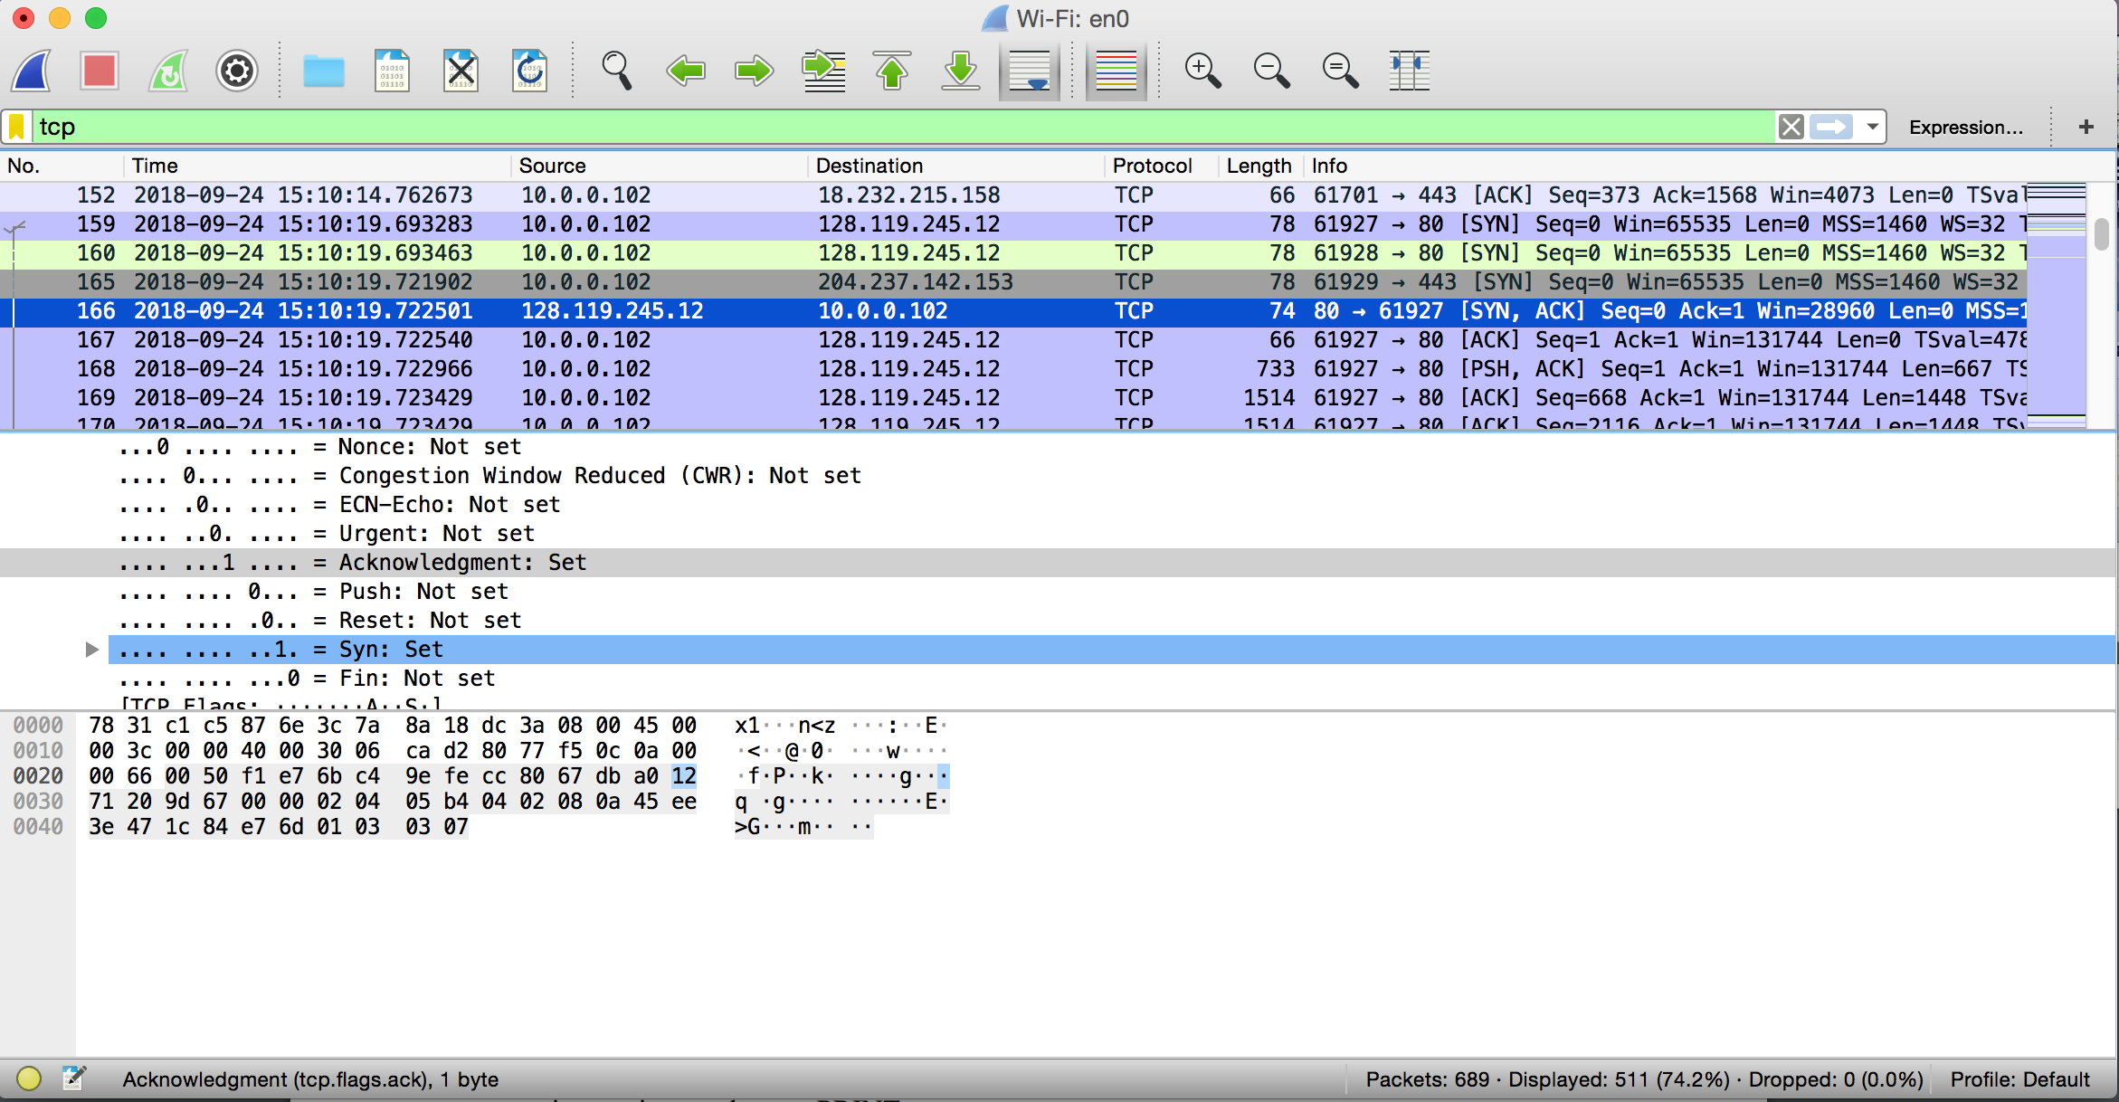

***Solution:***

The value of the ACKnowledgement field in the SYNACK segment is 1.

1. What is the sequence number of the TCP segment containing the HTTP POST command? Note: that to find the POST command, you’ll need to dig into the packet content field at the bottom of the Wireshark window, looking for a segment with a “POST” within its DATA field.

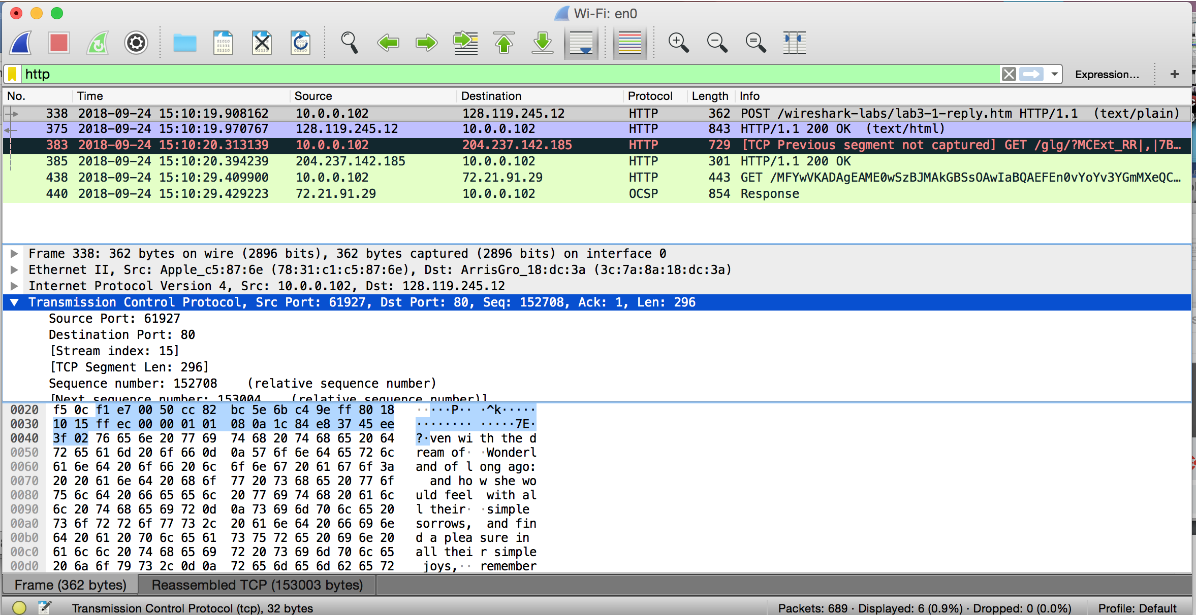

***Solution:***

*Number 383* segment is the TCP segment containing the HTTP POST command. The sequence number of this segment has the value of 152708.